Literature Circle Groups Roles for Novel:

Group A
Day | Kennedy | Cylie | Zane | Myles | Jason
1 | Illustrator | Discussion Director | Word Wizard | Researcher | Summarizer
2 | Passage Picker | Character Sketcher | Connector | Illustrator | Discussion Director
3 | Word Wizard | Researcher | Summarizer | Passage Picker | Character Sketcher
4 | Connector | Illustrator | Discussion Director | Word Wizard | Researcher
5 | Summarizer | Passage Picker | Character Sketcher | Connector | Illustrator
6 | Discussion Director | Word Wizard | Researcher | Summarizer | Passage Picker

Day | Matthew | Samaiyah | Skylar | Madison | Ryle
1 | Word Wizard | Illustrator | Character Sketcher | Discussion Director | Connector
2 | Summarizer | Passage Picker | Word Wizard | Connector | Illustrator
3 | Researcher | Word Wizard | Illustrator | Character Sketcher | Discussion Director
4 | Connector | Summarizer | Passage Picker | Word Wizard | Character Sketcher
5 | Discussion Director | Connector | Summarizer | Passage Picker | Word Wizard
6 | Character Sketcher | Discussion Director | Connector | Summarizer | Passage Picker

Day | Delana | Lori | Alanna | Khaliah | Aaron
1 | Researcher | Connector | Character Sketcher | Discussion Director | Illustrator
2 | Passage Picker | Word Wizard | Summarizer | Researcher | Connector
3 | Character Sketcher | Discussion Director | Illustrator | Passage picker | Word Wizard
4 | Summarizer | Researcher | Connector | Character Sketcher | Discussion Director
5 | Illustrator | Passage Picker | Word Wizard | Summarizer | Researcher
6 | Connector | Character Sketcher | Discussion Director | Illustrator | Passage Picker

Day | Calysta | Jazlyn | Aiyanna | Maurice | Lauren
1 | Discussion Director | Illustrator | Researcher | Character Sketcher | Connector
2 | Summarizer | Passage Picker | Word Wizard | Discussion Director | Illustrator
3 | Researcher | Character Sketcher | Connector | Summarizer | Passage picker
4 | Word Wizard | Discussion Director | Illustrator | Researcher | Character Sketcher
5 | Connector | Summarizer | Passage Picker | Word Wizard | Discussion Director
6 | Illustrator | Researcher | Character Sketcher | Connector | Summarizer

Literature Circle Roles Bookmarks

Passage Picker  Your job is to…  1. Pick 4 parts of the text that you found important, engaging or unusual.  2. Record them in your journal with the chapter and page numbers and explain why  These can be parts that are:  - Important  - Interesting  - Descriptive  - Funny  - Scary  - Sad  - Mysterious  - About the Setting  - Surprising | Word Wizard  Your job is to…  1. Find at least 4 special and unknown words in the text.  2. Write the words, definitions, the sentence from the book that uses the word, page number, and an picture explaining the word  3. Words should be:  - New  - Different  - Funny  - Strange  - Interesting  - Important  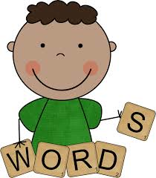 | Researcher  Your job is to…  1. Choose a topic or one given by teacher  2. Write at least 5 interesting facts about the topic | Connector  Your job is to…  Find and record 3 connections between the book and the outside world. (Label chapter & page numbers for each connection)  Connect your selection to:  - Text to Self (your own life)  - Text to text (Other stories)  - Text to World (Similar events at other times and places)

Summarizer  Your job is to…  1. Make a list of 5 key points (events)  2. Write 2- 3 sentences that tell what has happened in the reading so far.  2. Share your summary with the group  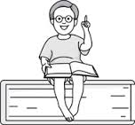 | Illustrator  Your job is to…  1. Draw a picture that depicts (shows) anything about the story that was engaging.  2. Write a caption (1-3 sentences) explaining what it is and how it is related to the reading  Your picture can be of:  - Character  - The setting  - An event  - A surprise  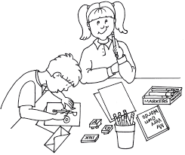  - A predictions of what will happen next | Discussion Director  Your job is to…  Write down 5 good questions that you think your group would want to talk about.  Record different questions with:  - Who  - What if  - How  - Where  - When  - Thinking  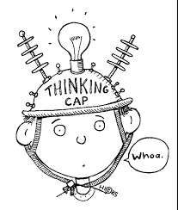 | Character Sketcher  Your job is to…  Sketch the character given by your teacher. Along with the sketch include the following:  - Name of the character under the sketch  - Write 3 adjectives for the character  - Find a quote that supports one of the adjectives  - Write it  - Page # & Paragraph #

